**REPORT ON FEEDBACK RATING CALCULATOR OR CSAT**

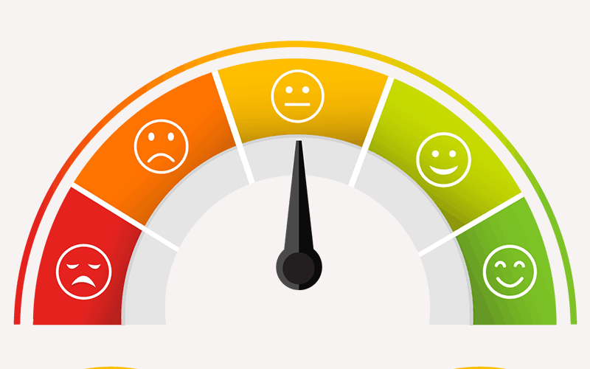**Approach-2**

***Name: Prajwal.M.S***

***USN: 1VE18EC070***

***Collage: Sri Venkateshwara Collage Of***

***Engineering***

**Overview:**

**The 2020 tech industries have been at a pretty bad situation due to the negative feedback rating on some good products,Let’s face it: the reality now is that only 1-2% of happy buyers will leave positive feedbacks while almost 100% of unhappy buyers will leave negative feedbacks. Therefore the negative feedbacks are given way too much weight in the current Feedback Rating calculation. The other 98-99% buyers received their orders as expected but will not leave any feedbacks. These orders are not even included in the current calculation. Hence to tackle this we will be designing a more dynamic ‘Feedback rating calculators’ which takes feedback from both positive and negative perspective to provide a better overall rating hence providing a better overview on online markets and good products!**

**Goals:**

**1. Help determine dynamic rating of a product**

**2. Provide better rating to customers.**

**3. Help build a better community online**

**Specification:**

**We will be considering if the customer is willing to provide a Positive/Negative Rating then we will be considering the various aspects of Positive/Negative rating and depending on the type of rating the customer is willing to provide we will set the metrics and then provide the right questions to decide the rating of a product.**

**Tools:**

**1. Jvdroid**

**2. Online java editor**

**Source Code:**

//Prajwal.M.S

//1VE18EC070

//Sri Venkateshwara collage of Engineering

//6363302562

//gowdaprajwal009@gmail.com

import java.util.Scanner;

public class CSAT{

public static void main(String[]args) {. //formula=score=(no of positive responses/total number of responses)*100

float p=0,t=0,score;

Scanner scan = new Scanner(System.in);

do {

System.out.println("Enter the total number of feedbacks");

t=scan.nextFloat();

if(t!=(int)t || t<0)

System.out.println("\n\nEnter a valid number");

} while(t!=(int)t || t<0);

do {

do {

System.out.println("\n\nEnter the number of +ve feedbacks");

p=scan.nextFloat();

if(p!=(int)p || p<0)

System.out.println("\n\nEnter a valid number");

} while(p!=(int)p || p<0)

if(p>t)System.out.println("\n\nThis isn't possible"); } while(p>t); score=(p/t)*100;

System.out.println("\n\nThe Customer Satisfaction score is " +score+"%");

scan.close();

} }

INPUT:

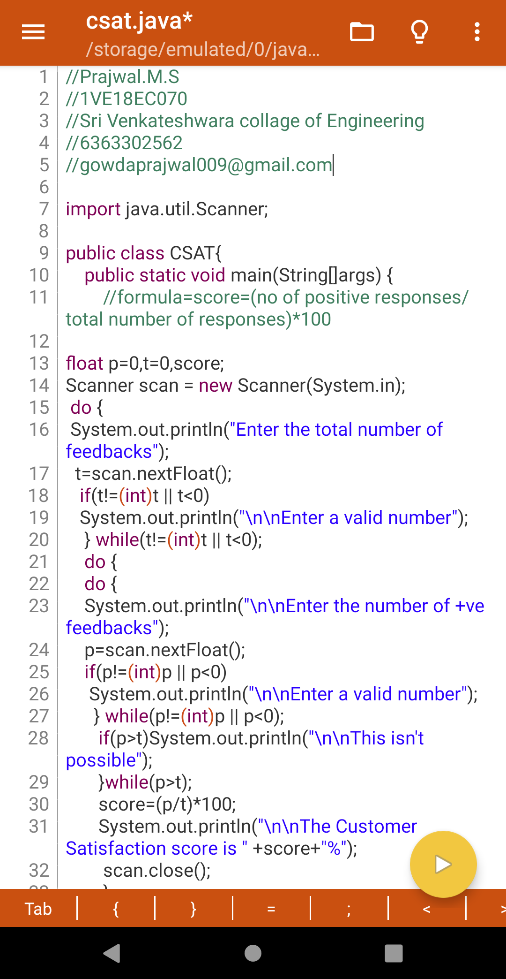

OUTPUT:

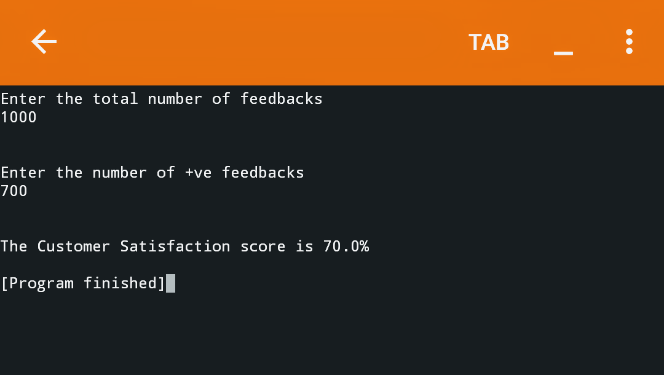

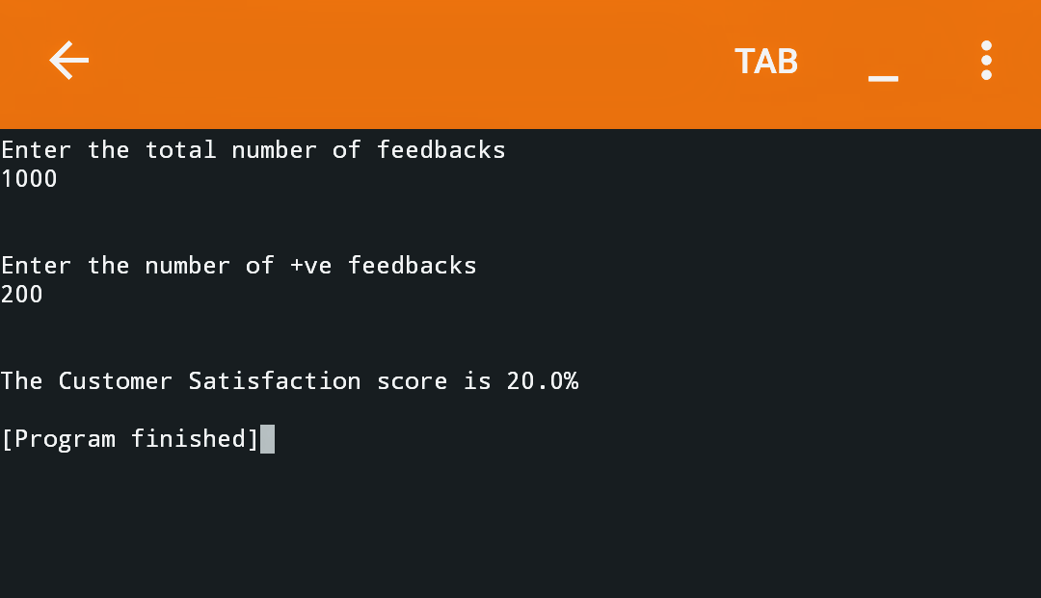



NAME : PRAJWAL MS

MOBILE NO : +91 6363 302 562

E MAIL : gowdaprajwal009@gmail.com